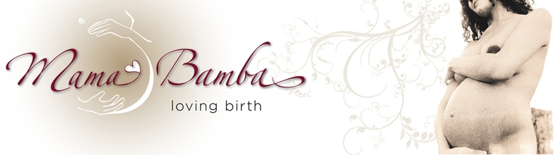
Abuse in the Workplace
Finding a Space for Compassion and Equanimity
Robyn Sheldon BA. RM.

How do we shift a societal paradigm of abuse?
Abusive habits are unconscious. Once we become aware of them they are no longer habits they are choices. Paradigms shift when we recognize the dissonant energy and make a conscious choice to move towards resonance and inclusivity. This shift can be immediate; it only requires a conscious change of perspective.
Inclusivity is a perspective that open-heartedly values and respects the external environment - even if it is abusive - by recognizing our interdependence with that environment. Inclusivity resonates with compassion, equanimity, joy and love. Exclusivity, on the other hand, arises out of a separative perspective, which contracts us into resistance against the external environment. It manifests as anger, rage, fear, bitterness, depression, guilt, shame, apathy etc.
There cannot be victimizers without victims. If we are in a situation we dislike (and the stories around the abuse indicate a dislike of this paradigm), and we are not effecting change, then we are playing a victim role.
We cannot shift a paradigm by moving from victim to victimizer, as that is only shifting roles within the paradigm. Therefore meeting the problem from a perspective of exclusivity – of a separate me or them attacked by a violent misuse of power, and choosing to attack it back – does not lead to resolution.
However, here’s the paradox, we cannot move from a victim/victimizer paradigm into an inclusive, holistic, respectful state of equality without starting at the point where we are now; telling the stories and sitting fully in the discomfort that arises when we feel the exclusive, ugly nature of the abuse.
We can choose to meet uncomfortable feelings by:
- Supressing them – this creates contraction, resistance and dis-ease.
- Expressing them – this creates a backlash of more of the same behaviour in return and keeps us caught in the cycle of abuse.
- Feeling them by simply staying present and letting the feeling wash through us, and once we are calm and centred finding an appropriate response to the situation.

Once we have become centred enough to maintain equilibrium in the face of any raw emotions arising out of witnessing or experiencing abuse, (which is the equivalent of staying open-hearted and simultaneously untroubled by the victimising external factors,) we move out of the paradigm of victim/victimiser into a place where we are in our integrity and capable of taking full responsibility for the situation.
It is not our responsibility to force society to change, because that comes from an ‘us and them’ perspective, which limits our ability to initiate change. Changing ourselves, making the conscious choice to move away from playing the game of victim/victimizer allows us to sit solidly and comfortably in a world of dissonance, without being deflected from our integrity or truth. From this perspective our responses arise out of compassion and equanimity and they will quite naturally be appropriate.
Because everyone longs for harmony, equality and respect, when victims or victimizers encounter somebody who embodies those qualities, they naturally make choices where they can begin to drop their defences – at least in relation to the person who is inclusive of and respectful of them. Even the angriest victimizer is just a frightened child who is longing for recognition underneath all the rage and armouring. Nelson Mandela, Desmond Tutu, Mahatma Ghandi are examples of people who created enormous paradigm shifts by maintaining an inclusive, respectful centeredness whilst never wavering from taking appropriate action in an inclusive way.
Abuse in our hospitals - from a perspective of inclusivity - recognizes the pain arising from a hierarchical, fear-based - or exclusive, medical model of care.
The model of care we presently use in our hospitals is exclusive and fear-based because:
- Disease and illness are seen as the enemy to be attacked and destroyed at all costs
- Patients are seen as inferior to medical practitioners
- It is mistrustful of anything except total control
Within this system the more intellectual knowledge we have, the more power we are accorded. This discrepancy in power has the potential to lead to abuse of those who are disempowered. The patient’s wisdom and body intelligence are usually dismissed as irrelevant within this paradigm.
Appropriate action therefore, not only requires addressing specific problems of abuse as they arise – through the channels that have already been instituted for dealing with them; reporting abuse etc. – but also through recognising that buying into the hierarchical structure as a valuable paradigm is perpetuating the problem of abuse. If we as individuals hold as much respect for ourselves and for patients as we do for consultants, we are creating a small shift in consciousness that has the potential to change the entire paradigm (consider ‘The Arab spring’ or ‘Occupy Wall street’ here), because everyone, even the abusers, deep down wants to be a part of a consciousness of equality. Everybody wants to be respected and listened to. Given enough real listening and mindful regard everyone softens their defences and contractions and begins opening up into a more inclusive way of interacting.

